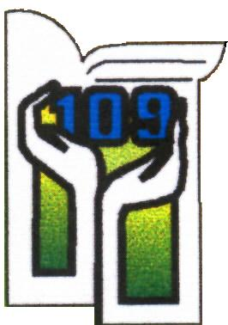

Recruitment regulations for admission to 1st grade of the Primary School no 109 in Łódź for the 2025/2026 school year
I. Legal Basis:
Based on the Education Law Act of December 14, 2016.
Resolution No. XLIII/1152/17 of the Łódź City Council from March 15, 2017.
Order No. 93/2025 of the Mayor of Łódź from January 17, 2025.
II. Recruitment Schedule:
General Classes:
May 5, 2025 - May 30, 2025 (submission of applications in the electronic system).
Integrative Classes:
May 5, 2025 - May 23, 2025 (submission of applications along with special education needs documentation).
Sports Classes:
May 5, 2025 - May 16, 2025 (submission of applications).
May 19, 2025 - May 20, 2025 (physical fitness tests).
May 23, 2025 (results of physical fitness tests).
Verification by school committees: May 5, 2025 - June 4, 2025.
Results announcement: June 11, 2025.
Confirmation of acceptance: June 11, 2025 - June 16, 2025.
Final list of accepted candidates: June 18, 2025.
III. Application Types:
- Registration:
  - For children living in the school's designated area.
  - Completed online, printed, signed, and uploaded to the system.
- Application:
  - For children outside the school's designated area.
  - Submitted online with supporting documents.
  - Special education needs applications must include appropriate documentation.
IV. Criteria for Non-District Applicants:
- Sibling attending the same school: 32 points.
- Attended a kindergarten in the school's district: 16 points.
- Sibling attending another educational institution in the district: 8 points.
- Child's disability: 4 points.
- Parent's workplace in the school's district: 2 points.
- School chosen as first preference: 1 point.

V. Additional Recruitment:
- Conducted if there are remaining vacancies after the primary recruitment process.
VI. Additional Recruitment Schedule:
- June 23, 2025 - July 4, 2025 (submission of applications).
- July 2, 2025 (physical fitness tests for sports classes).
- July 3, 2025 (results of fitness tests).
- July 11, 2025 (announcement of qualified candidates).
- July 11, 2025 - July 18, 2025 (confirmation of acceptance).
- July 22, 2025 (final list of accepted candidates).
VII. Appeal Procedure:
Parents can request a justification for rejection within 3 days of the announcement.
The committee must provide the justification within 3 days. Parents can appeal to the school principal within 3 days of receiving the justification. The principal has 3 days to respond. A further appeal can be made to the administrative court.

